**Example for downloading, unarchive and delete maven**

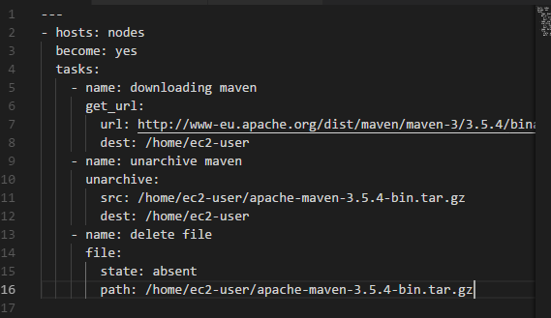

* We can list ansible tasks with below command
* **ansible-playbook jenkins.yml --list-tasks**

**Different tasks on different nodes:**

